Artemis Sportsman Solution Sonar Sailor
Fish Like a Deity

6/6/2024

Kenta Truong, Parker Barton, Lizbeth Martinez-Elias,
Oriol Vidal Vilalta, Chunfei Huang, Kade Hildreth

Introduction – Kenta Truong
In this report, we will provide a comprehensive overview of our business plan to launch our new product. The report will begin with a concise product description and an executive summary that outlines the key elements of the plan. Following this, an industry analysis will offer insights on growth rate and industry trends and size. We will then dive into a detailed company and product description, where a pains and gains graphic with analysis is provided. It will be followed by a market analysis to identify our target customers and market needs. The economics of the business will be assessed to understand the financials of our product including product fixed and variable costs, complemented by a marketing plan to discuss the overall marketing strategy using the “4-Ps”. Next, the product development plan will outline the major milestones of our product’s projected development costs, supported by an operations plan that details the business location and a table showing the major suppliers and customers in the supply chain. Financial projections will illustrate the Proforma Income Statement and Balance sheet as well the Trends-to-Demand chart, and we will specify the financing sought to support the business. Finally, we will summarize the key points and conclude with a reflection on the business’s potential.

Product Description – Kenta Truong
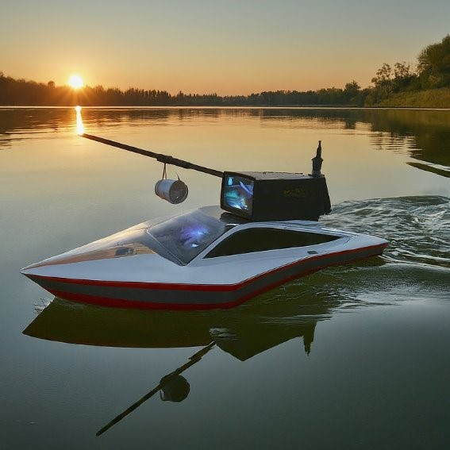
The Sonar Sailor revolutionizes the fishing experience using new technology, the remote-controlled boat is designed for avid anglers and fishing enthusiasts. The boat measures in at 24” x 12” x 6”, this sleek and compact boat is packed with features that help make the fishing experience better.
Some of the key components that make the boat are the carbon fiber material as well as the hull design which helps the boat combat rough conditions and waves any lake, river or pond might have. The boat is also powered by a LiPo battery which makes the boat lasts for hours without worrying about the boat dying during use.
Featuring a built-in tracker, sonar fish finder, and a high-definition camera, it delivers real-time data and live video feed straight to your phone via our user-friendly app interface. Since physical remote controls make it one more thing that can be lost; now you can effortlessly navigate the boat using your smartphone where the app serves as both the live feed as well as a remote control for the boat. The app provides easy to use and simple control over the boat, offering intuitive and responsive commands at your fingertips. Now you can effortlessly navigate your entire fishing spot without the person fishing to physically move, saving both gas and time. Ideal for lakes, rivers, and larger ponds, our innovative product helps you catch more fish in a shorter amount of time, offering a superior underwater view and making your fishing trips more productive and enjoyable.

Table of Contents – Kenta Truong

Introduction 2
Product Description 3
Table of Contents 5
Executive Summary 6
Industry Analysis 7
Company and Product Description 8
Market Analysis 10
Economics of Business 11
Marketing Plan 12
Product Development Plan 13
Operations Plan 14
Management Team 15
Overall Schedule 16
Financial Projections 17
Financing Sought 18
Summary 19
Conclusion 20

Executive Summary – Chunfei Huang

Team Members:  Lizbeth Martinez-Elias  Chunfei Huang  Parker Barton  Kade Hildreth  Kenta Truong  Oriol Vidal Vilalta  Industry: Fishing  Funding Request:  500, 000 from angel Investor  Use of Funds:  Y1 - Personal Funds, Friends & Family, Angel Investor.  Y2 – Commercial Bank, Business Angel  Y3 – Revenue  Operating expenses 3rd year is total of $4,533,036  Breakeven Quantity: 48, 931 units  Breakeven: 2.5 years  Y3 Projected Revenue: $34, 944, 000  Y3 Projected Net Profit: 20% | Product Description:  Sonar Sailor is a small electric remote-controlled boat with a sonar fish finder-built in.  Problem / Solution Fit:  Problem: Wasting time, bait, and resources on unsuccessful fishing or hunting trips causes frustration. Solution: Introducing a mobile scanning device that enables users to survey entire fishing spots without moving the boat, saving time and fuel. It helps catch more fish in less time, specifically designed for lakes, rivers, and large ponds. Differentiation: Unlike competitors like Sonar Bobber and Sonar Scanners, our solution offers greater mobility and coverage. Additionally, an app provides extra services, highlighting scanned hotspots and indicating fishing-friendly areas.  Target Customer:  Avid fishers and ages 20-40’s  Potential Market Size:  $20 B SAM  3% ANNUAL GROWTH RATE  $7 B SOM  Direct / Indirect Competitors  Garmin, Hawkeye, Sonar Bobber, Sonar Scanners  Business Model: Bricks & Clicks  Revenue Model:  Y1: ($114,170)  Y2: $1,531,779  Y3: $6,891,644  Team Roles / to fill:  Software Engineering  engineering

Industry Analysis – Parker Barton

The industry we’re in is recreational fishing, specifically freshwater fishing as our product is intended for lakes, rivers, and larger ponds. Given the map below, our initial target audience to get our product out there is the states near East South Central and South Atlantic regions. This percentage of people is 35%, given that the recreational fishing industry generates $51.2 billion we estimate that our initial market size is $17.92 Billion. Narrowing our market even further we estimate that the audience that will most likely be interested in our product is younger fishermen between their 20s-40s and avid fishermen alike as there’s no limit to what people will buy for their favorite hobbies. This comes out to about 30% of the demographic mentioned previously.
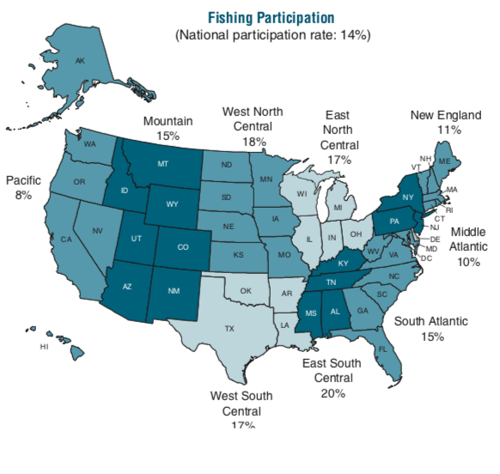
The structure of our market is retail fronts and online stores as well. The biggest store fronts for recreational fishing are Cabela's, Walmart, and Bass Pro Shops. With an increase of 2 million additional people fishing in 2021 compared to the year before and a total of 52.4 million Americans fishing in total, there’s roughly a 3% growth rate in the recreational fishing market. Since 2015 recreational fishing has had a positive trend and we believe this will continue relatively consistently.

Company and Product Description – Parker Barton

The value of our product comes from the pains of our customers who stated that problems they had while fishing included not catching or seeing any fish, along with wasting time due to being in the wrong spot where there aren’t any fish. Our product, the sonar sailor, is designed to make fishing a more streamlined and efficient process so our customers can catch more fish in less time.
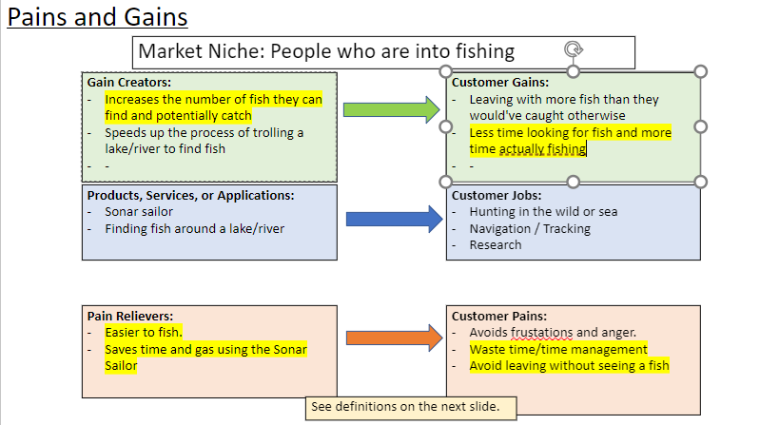
Our product is a 2-foot-long remote-controlled boat with a camera to see where you’re going and a sonar scanner so you can scan for fish all around whatever fishing spot, you’re at. We have an app that pairs with it to get the feed from the camera, sonar scanner, and within the app there are features that can be used to drive itself around the body of water without you having to worry about it crashing into anything.
The biggest thing that sets us apart from all our competitors is the range our device can go, all the other products in our market either physically attach to a boat or are some sort of device that can be connected to your fishing line. With both options, the devices can only be used up to 800 feet or as far as you can cast. With ours you can explore up to 5 miles away, essentially allowing you to scope out an entire lake and find the fish without ever moving the boat you’re on.

Market Analysis – Oriol Vidal Vilalta
Major Market Segment and Niche
Major Market Segment:
- Demographics: Predominantly male fishers aged 20s to late 40s.
- Lifestyle: Enthusiastic about outdoor activities, particularly fishing. Enjoys the challenge and relaxation that comes with the hobby. Values both innovative and traditional fishing gear.
- Context: These individuals are often frustrated by unsuccessful fishing trips and the loss or breakage of their equipment. They are looking for solutions that enhance their fishing experience, providing real-time data on underwater conditions and robust, reliable gear.
Competitors
Sonar Sailor Product
- Price: $499.99
- Features: Self-driving, self-righting, camera, GPS, durable.
STRIKER
- Price: $179.99
- Features: Castable fish finder, app and Wi-Fi remote controlled, no self-driving, no self-righting, no camera, no GPS, not durable.
FISHPOD X5
- Price: $99.99
- Features: Portable deeper smart sonar, app and Wi-Fi remote controlled, no self-driving, no self-righting, camera, GPS included.
ECHOMAP UHD
- Price: $999.99
- Features: Fish finder with optical boat mount, touchscreen or optional remote controlled, GPS included, waterproof casing.

Indirect Competitors:
- GoPro
  - Products: Action cameras for underwater recording.
  - Strengths: Versatile use, high-quality video.
  - Weaknesses: Not specifically designed for fishing, additional equipment needed for underwater use.
- Yamaha Marine
  - Products: Outboard motors and marine engines.
  - Strengths: Trusted brand, durable and reliable products.
  - Weaknesses: Not directly related to fish finding, higher cost.
- Bass Pro Shops (Private Label)
  - Products: Fishing gear and accessories.
  - Strengths: Wide range of products, competitive pricing.
  - Weaknesses: Mixed quality, not specialized in high-tech solutions.
Competitor Comparison Matrix
Company Name | Artemis Sportsman Solutions | Garmin | HawkEye | Garmin
Product Name | Sonar Sailor | STRIKER | FishPod 5X | ECHOMAP UHD 93sv
Unit Price | $499.99 | $179.99 | $99.99 | $999.99
Range of Device | 5 miles | 200 ft castable range | 800 ft Bluetooth capabilities | 750 ft on either side of boat
Other attributes | -Gps-Camera-25 mph top speed | GPS Included, and option of App usage | App, virtuview mode | -Preloaded inland map of U.S.-Many Sensor and Sonar features.
Control Device | App for any compatible devices | Cast and reel | Cast and reel | Touchscreen with Keyed Assist

Analysis
1. Price Range:
- Low-end: FISHPOD X5 at $99.99
- Mid-range: STRIKER at $179.99
- Premium: Sonar Sailor at $499.99
- High-end: ECHOMAP UHD at $999.99
2. Feature Comparison:
- Sonar Sailor offers a comprehensive set of features including self-driving, self-righting, camera, and GPS at a mid-to-high price point.
- STRIKER lacks several advanced features (self-driving, self-righting, camera, GPS) and is less durable, making it the most basic option.
- FISHPOD X5 provides a camera and GPS but lacks self-driving and self-righting capabilities, offering a good balance of features at a very affordable price.
- ECHOMAP UHD is the most expensive and provides high durability, GPS, and waterproof casing but lacks camera and self-driving/self-righting features, targeting serious or professional fishers who need reliable and advanced equipment.
3. Perceived Value:
- Sonar Sailor stands out for its unique combination of self-driving and self-righting capabilities, making it attractive to users looking for convenience and cutting-edge technology. The addition of a camera and GPS at a price significantly lower than the ECHOMAP UHD makes it a competitive option in the higher end of the market.
- STRIKER is appealing to budget-conscious users who need a basic, affordable fish finder without advanced features.
- FISHPOD X5 offers excellent value for its price with camera and GPS features, appealing to users who want more than the basics but at a lower price.
- ECHOMAP UHD targets the high-end market, providing robust features and reliability for professional use, justifying its high price.
Sonar Sailor positions itself effectively in the market by offering a balanced mix of advanced features and competitive pricing. By emphasizing its self-driving, self-righting, camera, and GPS capabilities, along with durability, Sonar Sailor can attract serious fishers who are willing to invest in high-quality, innovative equipment. The product stands out from its direct competitors (STRIKER and FISHPOD X5) by offering features that enhance user convenience and the overall fishing experience, while still being more affordable than the high-end ECHOMAP UHD.

Economics of Business – Kade Hildreth

Our Sonar Sailor is a novel product intended for recreational fishing that will be largely sold and marketed through sportsman stores and internet channels. here below will be a thorough examination of the revenue-generating factors and how these channels will affect our market share in recreational fishing:

1. Product Sales: Total Units Sold in Volume

Online Sales: Targeting fishing fans worldwide, online platforms enable a wider reach. Because internet buying is convenient and allows you to target niche audiences, this can raise the volume of units sold dramatically. It will also drive customers to our website where other products in the future will be sold.

Brick-and-mortar Sales: Having a physical presence in sportsman stores allows products to be immediately available, which can draw in impulsive purchasers and those who would rather see the goods in person before making a purchase. It also develops trust by means of well-established retail alliances.
Pricing Methodology:

Competitive Pricing: The cost must be reasonable when compared to other fishing accessories available on the market. Price-conscious consumers may be drawn to businesses that offer competitive or value-based pricing since online platforms make it simple to compare prices.

Premium Pricing: By offering demos and individualized customer care, the Sonar Sailor may be positioned as a premium product in physical locations, which will help to justify a higher price point.

In-Store Promotions: Organizing in-store events or promotions in conjunction with sportsmen stores can boost sales and visibility. Trials and demonstrations can improve client satisfaction and increase revenue.
2. Online Marketing: Market Reach and Customer Engagement
Social Media Campaigns: Using social media channels to reach out to communities and enthusiasts who enjoy recreational fishing by offering interesting material, discounts, and endorsements.
SEO and material Marketing: Producing informative material can raise search engine ranks and increase organic traffic to an online store. Examples of this type of content include fishing advice, product reviews, and tutorials.
Marketing within stores:

Marketing Plan – Oriol Vidal Vilalta
4-Ps Framework: Year 1, Year 2, and Year 3
Time Period | Product | Price | Place | Promotion
Year 1 (Q1) | Launch Sonar Sailor with all key features (self-driving, self-righting, camera, GPS, durable). | Introductory price of $499.99. Early bird discounts for pre-orders. | Available online through our website and Amazon. Limited availability in select retail stores. | Launch social media campaigns on Instagram and Facebook. Partner with influencers in the fishing community.
Year 1 (Q2) | Collect user feedback for potential product improvements. | Maintain introductory pricing, offer rental options at marinas. | Increase availability in major sporting goods stores (Cabela's, Sportsman's Warehouse). | Introduce rental options at marinas. Start advertising in fishing magazines and online forums.
Year 1 (Q3) | Release product updates based on user feedback. | Continue with $499.99 pricing, introduce bundle offers with accessories. | Expand to specialty fishing stores. Ensure product availability in high-traffic locations. | Host sponsored fishing events and contests. Collaborate with relevant YouTube channels for product reviews.
Year 1 (Q4) | Prepare for holiday season with special edition releases. | Offer holiday promotions and discounts. | Ensure sufficient stock in all retail and online channels. | Launch holiday promotions and discounts. Engage in targeted email marketing campaigns.
Year 2 | Introduce new features and accessories based on customer feedback. | Evaluate pricing strategy based on market response and competition. Adjust if necessary. | Continue expansion into more retail stores and specialty shops. Enhance e-commerce platform. | Increase budget for social media marketing. Expand marina partnerships. Start sponsoring larger fishing tournaments.
Year 3 | Develop next-gen Sonar Sailor with enhanced features. | Introduce a premium version at a higher price point. Offer loyalty discounts to existing customers. | Nationwide distribution in major fishing and outdoor stores. Strong online presence. | Launch nationwide advertising campaigns in major fishing and outdoor magazines. Increase presence at industry trade shows.

MARCOM Strategy
Time Period | Advertising & Promotions Activities
Year 1 (Q1) | Launch social media campaigns on Instagram and Facebook. Partner with influencers in the fishing community.
Year 1 (Q2) | Introduce rental options at marinas. Start advertising in fishing magazines and online forums.
Year 1 (Q3) | Host sponsored fishing events and contests. Collaborate with relevant YouTube channels for product reviews.
Year 1 (Q4) | Launch holiday promotions and discounts. Engage in targeted email marketing campaigns.
Year 2 | Continue social media marketing with increased budget. Expand marina partnerships. Start sponsoring larger fishing tournaments.
Year 3 | Launch nationwide advertising campaigns in major fishing and outdoor magazines. Increase presence at industry trade shows.
Year 5 | Focus on maintaining a strong online presence. Sponsor major fishing competitions and festivals. Develop loyalty programs.

Distribution Strategy
Channel | Description
Retail Stores | Partner with major sporting goods stores like Cabela’s and Sportsman’s Warehouse. Ensure product availability in high-traffic retail locations.
Specialty Stores | Stock products in specialty fishing and outdoor stores. Train store staff to highlight the unique features and benefits of the products.
Online Channels | List products on Amazon and other major e-commerce platforms. Develop an official website with e-commerce capabilities for direct purchases.
Marina Rentals | Offer rental options at marinas to allow customers to try before they buy. Provide on-site demonstrations and training sessions at marinas.

Methods of Purchase
Method | Description
Direct Procurement | Customers can purchase products directly through our official website or at retail locations.
Contract Purchasing | Establish contracts with fishing clubs, tour operators, and outdoor adventure companies for bulk purchases.

Major Sales Locations
Location | Description
Sporting Goods Stores | Focus on high-traffic sporting goods stores to reach a large customer base.
Marinas | Utilize marinas as strategic sales points where potential customers are already engaged in fishing activities.
Online | Maximize online sales through Amazon and our own e-commerce platform, ensuring ease of access and convenience for customers.

Customer Payment Process
Method | Description
Online Payments | Customers can pay using credit/debit cards, PayPal, and other popular payment methods. Secure payment gateways to ensure customer data protection.
In-store Payments | Accept various payment methods including cash, card, and mobile payments.
Subscription Services | Offer subscription plans for ongoing access to premium features and regular updates.

Ensuring Repeat Business and Customer Support
Aspect | Description
Customer Support | Provide excellent customer service through multiple channels (phone, email, live chat). Offer comprehensive user manuals, FAQs, and video tutorials.
Loyalty Programs | Develop a loyalty program that rewards repeat purchases and referrals. Offer exclusive discounts and early access to new products for loyal customers.
Regular Engagement | Maintain regular communication with customers through newsletters and social media updates. Gather customer feedback to continuously improve products and services.
Product Updates | Provide regular updates and enhancements to products, ensuring they meet evolving customer needs. Offer upgrade options for existing customers at discounted rates.
Community Building | Foster a community around the brand through social media groups, forums, and sponsored events. Encourage customers to share their experiences and tips, creating a sense of belonging and engagement.

Product Development Plan – Lizbeth Martinez-Elias

In the following years, Artemis Sportsman Solutions plans to trademark the company name and obtain a patent for the Sonar Sailor. In this way, future companies will not be able to duplicate our work and profit from our ideas.

Operations Plan – Kade Hildreth

Sonar Sailor Business Locations' Facilities, Equipment, and Business Locations:
Head Office: New Jersey
Function: Sales, marketing, administration, and management.
Office space, conference rooms, IT infrastructure, and communication systems are among the facilities required.
South Carolina warehouse
Function: Distribution, order fulfillment, and storage.
Large warehouse area with shipping docks, shelves, packaging stations, and inventory control systems is required.
Important Equipment and Facilities:
Office Spaces:
Chairs, desks, and other office supplies
servers, workstations, and networking hardware
Teleconferencing technology and projectors in conference rooms
Administrative instruments and office supplies
Storage Facilities:
Shelves and storage containers
Stations for packaging and shipping
Pallet jacks and forklift trucks
Software for managing inventories
systems of security.

Equipment:
Cameras: Sourced from China
Remote Control Boats: Sourced from Canada
Sonars: Sourced from Kansas
Additional packaging and labeling equipment for warehouse operations

Entity | Role In supply chain | Negotiating power | Factors Affecting Negotiation Power
Suppliers:
DJI (Cameras) | Supplier (china) | Low Power | Very high competition for cameras in the market, potential other sourcing options
Hobby Wholesale (remote control boat) | Supplier (Canada) | Medium Power | Very niche product, fewer alternatives, importance of quality and reliability
Sonar (Garmin) | Supplier (Kansas, USA) | Medium-High Power | Very close in proximity, reduces shipping cost and specialized products more available.
Customers:
Online Shoppers | End Consumer | High Power | Direct sales, ability to reach a large audience through marketing
Sportman Retails | Retailers | Medium Power | Establish market presence, but potential for strong partnerships or bulk orders
Marinas | End Consumer/ Retailers | High Power | Community engagement, win win situation for both parties.

Management Team – Chunfei Huang
ACCOUNTING & ANALYTICS - Kenta Truong - Accounting Major
Handle financial data analysis, providing insights to support strategic decision-making, budgeting, and financial forecasting within the organization, leveraging both accounting principles and analytical techniques.
BUSINESS & MARKET DEVELOPMENT - Oriol Vidal Vilalta - Management Major
Identifying new business opportunities, conducting market research, and developing strategies to expand the company's market presence and increase profitability, drawing on management principles and market analysis.
ACCOUNTING & PRODUCT TESTING - Parker Barton - Accounting Major
They would oversee product testing processes, ensuring compliance with quality standards, regulatory requirements, and customer expectations, while also managing financial aspects related to product development and testing.
ADMINISTRATION - Kade Hildreth - Business Administration Major
Handle administrative tasks such as office management, human resources, and logistical support, ensuring smooth day-to-day operations and efficient resource allocation within the organization.
DESIGN DEVELOPMENT - Lizbeth Martinez-Elias - Interior Design Major
Lead design projects, translating client needs into creative and functional interior design solutions, while also managing project timelines, budgets, and stakeholder communications to ensure successful project delivery.
DATA ANALYTICS - Chunfei Huang - Computer Science Major
Leverage data analysis techniques and programming skills to extract insights from large datasets, identify trends, and drive data-driven decision-making processes within the organization, contributing to business optimization and strategic planning.

Roles Still Need to be Filled:
SOFTWARE ENGINEERING
This role would create and maintain software solutions tailored to the organization's needs, enhancing efficiency, security, and user experience through innovative coding and system optimization.
ENGINEER
This position would contribute by designing and optimizing processes or systems, ensuring quality, compliance, and efficiency within the organization, whether in manufacturing, technology, or other fields.

Overall Schedule – Lizbeth Martinez-Elias

Quarter 1 | Research and Development:  In this phase we will be conducting in depth research on the fishing industry, target audience needs, and competitor analysis. We will also be developing a detailed product specification sheet outlining features, functionalities, and the target price point. Begin prototype.
Quarter 2 | Negotiate with Suppliers + Prototype:  After some research on different potential suppliers, we will conduct negotiations from some of the suppliers to review prices, terms, and delivery schedules.  With the prototype we will be addressing any performance issues identified during testing.
Quarter 3 | Finalize Negotiation:  In this phase we will have locked in the agreed-upon terms with formal contracts with the best fit suppliers. Also, selecting final materials based on the supplier options, cost, and performance.
Quarter 4 | Start Making Product:  We will be working with our suppliers to establish a detailed production schedule. As well as placing orders with our suppliers for all the necessary components.
Year 2 | Bring to Retail Front:  Product will be launched, and we will negotiate distribution deals with retail stores and online stores. In this phase we will also be implementing our marketing and sales strategies.
Year 3 | Refine Product:  Through survey, product reviews, customer support interactions, and social media engagement we will be collecting customer feedback. After analyzing it we will prioritize areas for improvement to reach customer satisfaction.

Financial Projections – Parker Barton
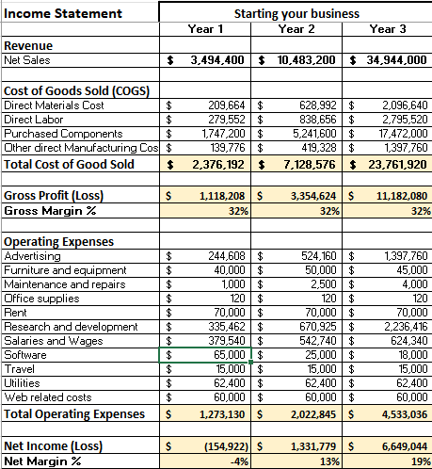
Looking at our projected income statements we’re looking pretty good financially. The first year we expect to take a bit of a hit since we are a new and advanced product compared to others on the market. We do expect it to be exactly what anglers are looking for, which is why we expect to make over a million in the second year. Our operating expenses slowly get higher as we anticipate an increase in advertising, research and development, and more staff hires in the warehouse as we get more orders in.
Taking into consideration our trends to demand this would mean that we expect to capture a very miniscule percentage of the recreational freshwater fishing industry in the southern and eastern United States. The estimated profit and net income are slightly off due to one of the percentages being rounded and the other not, but they both indicate around the same values we believe to be true.
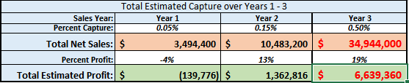
For our funding resources we are requesting $500,000 from angel investors in exchange for 10% of our company. This money will be used to help start up our company, pay for inventory, and advertising as well. We estimate around midway through year 3 we will hit our breakeven point and be able to thrive off only profits at that point and on.

Financing Sought – Kade Hildreth

Financing Sought:
- Amount: $500,000
- Equity Offered: 10% of the company
- Additional Terms: Royalties up to $5 million
- Additional Expectations: Expertise in marketing and mentorship from angel investors

Company Valuation:
- Pre-Money Valuation: $4.5 million
  - Calculation: ($500,000 for 10% equity implies a total company valuation of $5 million post-investment. Subtracting the $500,000 investment gives a pre-money valuation of $4.5 million.)

Major Milestones and Use of Equity Funding
- First Year: Operational Expenses
  - Amount Allocated: $150,000
  - Milestones:
    - Establish Headquarters and Warehouse Operations: Setting up office in New Jersey and warehouse in South Carolina.
    - Initial Inventory Purchase: Securing an initial stock of cameras from China, remote control boats from Canada, and sonars from Kansas.
    - Hiring Key Personnel: Bringing on board essential staff including management, marketing, and customer service teams.
    - Developing Online and In-Store Sales Channels: Building an e-commerce platform and establishing relationships with brick-and-mortar sportsman stores.
    - Initial Marketing Efforts: Launching preliminary marketing campaigns to create brand awareness and attract early adopters.
- Second Year: Production in Bulk and Advertisement
  - Amount Allocated: $250,000
  - Milestones:
    - Scaling Production: Increasing production capacity to meet growing demand, ensuring consistent supply of high-quality products.
    - Bulk Purchasing: Securing better terms with suppliers through bulk purchases, thereby reducing unit costs.
    - Expanded Marketing Campaigns: Investing heavily in advertising across digital platforms, social media, and fishing-related media to drive sales.
    - Market Penetration Strategies: Engaging in more extensive market research and implementing targeted campaigns to penetrate deeper into the recreational fishing market.
    - Sales and Distribution Expansion: Enhancing logistics to ensure timely delivery and exploring additional sales channels.
- Third Year: Research and Development (R&D)
  - Amount Allocated: $100,000
  - Milestones:
    - Product Innovation: Investing in R&D to improve the Sonar Sailor’s features and incorporate new technologies.
    - New Product Development: Exploring opportunities for new product lines or enhancements to meet evolving customer needs and market trends.
    - Prototyping and Testing: Creating prototypes of new products or product upgrades and conducting rigorous testing to ensure quality and performance.
    - Patents and Intellectual Property: Securing patents and protecting intellectual property for new innovations to maintain a competitive edge.
    - Customer Feedback Integration: Utilizing customer feedback to guide product development and ensure new releases meet market demands.

Value to Angel Investors or Venture Capital Firms

Strategic Value Proposition:
- High Growth Potential: The recreational fishing market is large and growing, offering significant opportunities for expansion.
- Innovative Product: The Sonar Sailor offers unique value to fishing enthusiasts, combining advanced sonar technology with user-friendly design.
- Diverse Revenue Streams: Revenue from both online sales and physical retail stores reduces risk and maximizes market reach.
- Experienced Management: The founders and management team bring relevant industry experience and a clear vision for growth.

Financial Value Proposition:
- Attractive Valuation: A pre-money valuation of $4.5 million positions the company attractively for investors seeking high returns.
- Royalties Up to $5 Million: Provides an additional layer of financial security and potential returns for investors.
- Mentorship and Expertise: The involvement of experienced angel investors can accelerate growth through strategic guidance and industry connections.

Summary – ChunFei Huang
- Product Description:
  - Introduction of Sonar Sailor, a remote-controlled boat revolutionizing fishing.
  - Features include sonar fish finder, high-definition camera, and smartphone control.
  - Carbon fiber construction ensures durability and LiPo battery provides long-lasting power.
- Market Analysis:
  - Target customers: Avid fishermen aged 20s to late 40s.
  - Estimated market size: $20 billion SAM with 3% annual growth rate.
  - Direct competitors include Garmin, Hawkeye, and Sonar Bobber.
- Marketing Plan:
  - Year 1 focuses on social media campaigns, influencer partnerships, and retail presence.
  - Year 2 introduces new features, expands retail distribution, and enhances e-commerce.
  - Year 3 launches nationwide advertising campaigns and increases presence at trade shows.
- Financial Projections:
  - Expect initial losses in Year 1 with breakeven in Year 2 and significant profit by Year 3.
  - Seeking $500,000 from angel investors for startup costs, inventory, and marketing.
  - Breakeven quantity: 48,931 units with projected Year 3 revenue of $34,944,000.
- Operations Plan:
  - Focus on trademarking the company name and obtaining a patent for Sonar Sailor.
  - Establishing contracts with suppliers and manufacturing processes.
- Where are we going from here:
  - Execute the marketing plan to increase brand awareness and market penetration.
  - Continuously gather customer feedback to refine the product and improve customer satisfaction.
  - Expand operations and distribution channels to reach a wider audience and maximize profitability.
Top of Form
Bottom of Form

Conclusion – Lizbeth Martinez-Elias
The Sonar Sailor presents a compelling solution for the recreational fishing industry. With its advanced features, competitive pricing, and innovative remote-control design, this boat is set to enhance the fishing experience for avid anglers and fishing enthusiasts. With a strong team, a well-defined marketing strategy, and a focus on continues improvement, the Sonar Sailor is positioned for significant growth and profitability in the years to come.

